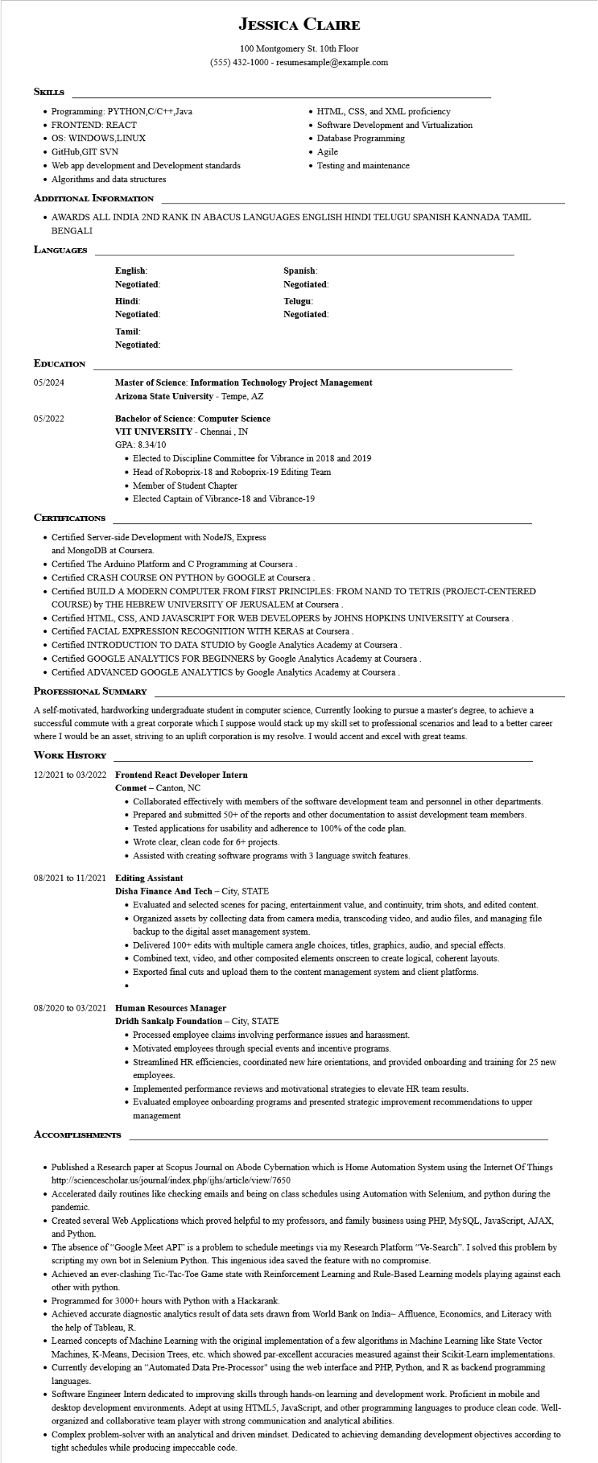
JESSICA CLAIRE
100 Montgomery St. 10th Floor
(555) 432-1000 - resumesample@example.com
SKILLS
• Programming: PYTHON,C/C++,Java
• FRONTEND: REACT
• OS: WINDOWS,LINUX
• GitHub, GIT SVN
• Web app development and Development standards
• Algorithms and data structures
ADDITIONAL INFORMATION
• HTML, CSS, and XML proficiency
• Software Development and Virtualization • Database Programming
Agile
•
Testing and maintenance
⚫ AWARDS ALL INDIA 2ND RANK IN ABACUS LANGUAGES ENGLISH HINDI TELUGU SPANISH KANNADA TAMIL BENGALI
LANGUAGES
English: Negotiated:
Hindi:
Negotiated:
Tamil:
Negotiated:
Spanish: Negotiated:
Telugu:
Negotiated:
EDUCATION
05/2024
05/2022
CERTIFICATIONS
Master of Science: Information Technology Project Management Arizona State University - Tempe, AZ
Bachelor of Science: Computer Science VIT UNIVERSITY - Chennai, IN GPA: 8.34/10
• Elected to Discipline Committee for Vibrance in 2018 and 2019
• Head of Roboprix-18 and Roboprix-19 Editing Team
• Member of Student Chapter
• Elected Captain of Vibrance-18 and Vibrance-19
• Certified Server-side Development with NodeJS, Express and MongoDB at Coursera.
• Certified The Arduino Platform and C Programming at Coursera
• Certified CRASH COURSE ON PYTHON by GOOGLE at Coursera
• Certified BUILD A MODERN COMPUTER FROM FIRST PRINCIPLES: FROM NAND TO TETRIS (PROJECT-CENTERED COURSE) by THE HEBREW UNIVERSITY OF JERUSALEM at Coursera
• Certified HTML, CSS, AND JAVASCRIPT FOR WEB DEVELOPERS by JOHNS HOPKINS UNIVERSITY at Coursera.
• Certified FACIAL EXPRESSION RECOGNITION WITH KERAS at Coursera
• Certified INTRODUCTION TO DATA STUDIO by Google Analytics Academy at Coursera.
• Certified GOOGLE ANALYTICS FOR BEGINNERS by Google Analytics Academy at Coursera.
• Certified ADVANCED GOOGLE ANALYTICS by Google Analytics Academy at Coursera
PROFESSIONAL SUMMARY
A self-motivated, hardworking undergraduate student in computer science, Currently looking to pursue a master's degree, to achieve a successful commute with a great corporate which I suppose would stack up my skill set to professional scenarios and lead to a better career where I would be an asset, striving to an uplift corporation is my resolve. I would accent and excel with great teams.
WORK HISTORY
12/2021 to 03/2022 Frontend React Developer Intern Conmet Canton, NC
• Collaborated effectively with members of the software development team and personnel in other departments.
• Prepared and submitted 50+ of the reports and other documentation to assist development team members.
• Tested applications for usability and adherence to 100% of the code plan.
• Wrote clear, clean code for 6+ projects.
• Assisted with creating software programs with 3 language switch features.
08/2021 to 11/2021 Editing Assistant
Disha Finance And Tech - City, STATE
• Evaluated and selected scenes for pacing, entertainment value, and continuity, trim shots, and edited content. • Organized assets by collecting data from camera media, transcoding video, and audio files, and managing file backup to the digital asset management system.
• Delivered 100+ edits with multiple camera angle choices, titles, graphics, audio, and special effects.
• Combined text, video, and other composited elements onscreen to create logical, coherent layouts.
• Exported final cuts and upload them to the content management system and client platforms.
08/2020 to 03/2021 Human Resources Manager
Dridh Sankalp Foundation - City, STATE
ACCOMPLISHMENTS
• Processed employee claims involving performance issues and harassment.
• Motivated employees through special events and incentive programs.
• Streamlined HR efficiencies, coordinated new hire orientations, and provided onboarding and training for 25 new employees.
• Implemented performance reviews and motivational strategies to elevate HR team results.
• Evaluated employee onboarding programs and presented strategic improvement recommendations to upper management
• Published a Research paper at Scopus Journal on Abode Cybernation which is Home Automation System using the Internet of Things http://sciencescholar.us/journal/index.php/ijhs/article/view/7650
Accelerated daily routines like checking emails and being on class schedules using Automation with Selenium, and python during the pandemic.
• Created several Web Applications which proved helpful to my professors, and family business using PHP, MySQL, JavaScript, AJAX, and Python.
• The absence of "Google Meet API" is a problem to schedule meetings via my Research Platform "Ve-Search". I solved this problem by scripting my own bot in Selenium Python. This ingenious idea saved the feature with no compromise.
Achieved an ever-clashing Tic-Tac-Toe Game state with Reinforcement Learning and Rule-Based Learning models playing against each other with python.
• Programmed for 3000+ hours with Python with a Hackarank.
Achieved accurate diagnostic analytics result of data sets drawn from World Bank on India- Affluence, Economics, and Literacy with the help of Tableau, R.
• Learned concepts of Machine Learning with the original implementation of a few algorithms in Machine Learning like State Vector Machines, K-Means, Decision Trees, etc. which showed par-excellent accuracies measured against their Scikit-Learn implementations.
• Currently developing an "Automated Data Pre-Processor" using the web interface and PHP, Python, and R as backend programming languages.
• Software Engineer Intern dedicated to improving skills through hands-on learning and development work. Proficient in mobile and desktop development environments. Adept at using HTML5, JavaScript, and other programming languages to produce clean code. Well- organized and collaborative team player with strong communication and analytical abilities.
• Complex problem-solver with an analytical and driven mindset. Dedicated to achieving demanding development objectives according to tight schedules while producing impeccable code.

